Lichen, Moss, Liverwort Structure

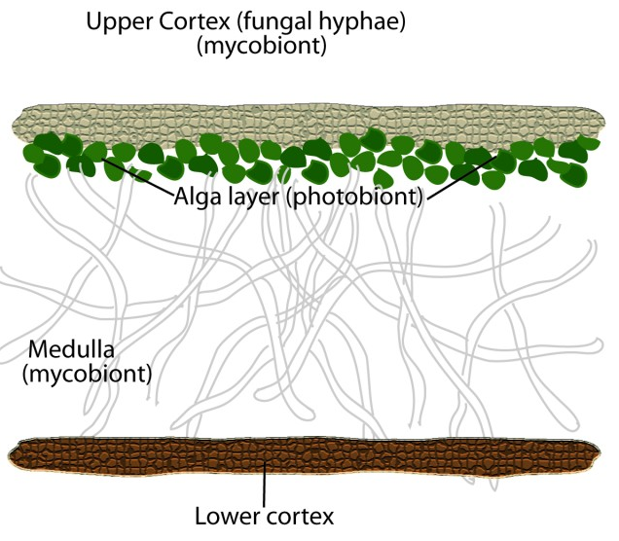
Lichen

Lichens are a combination of fungi, algae, and sometimes cyanobacteria.

The picture is of a foliose lichen. The top and bottom cortex differ in color.

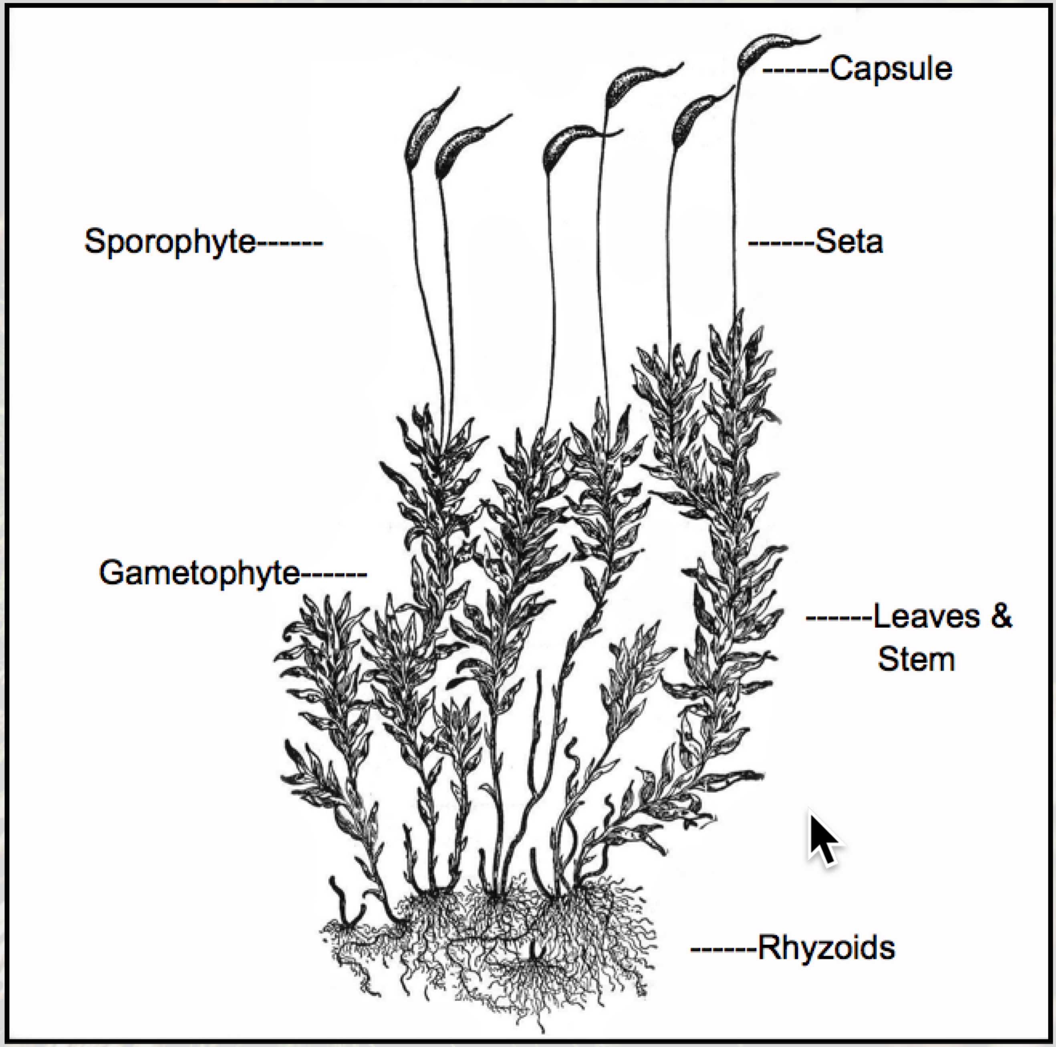
Moss

Moss is a non-vascular plant. Unlike other spore-producing plants, the gametophyte generation is the dominamt generation. The gametophyte is haploid; the sporophyte is diploid.

The capsules open at the tip to release spores.

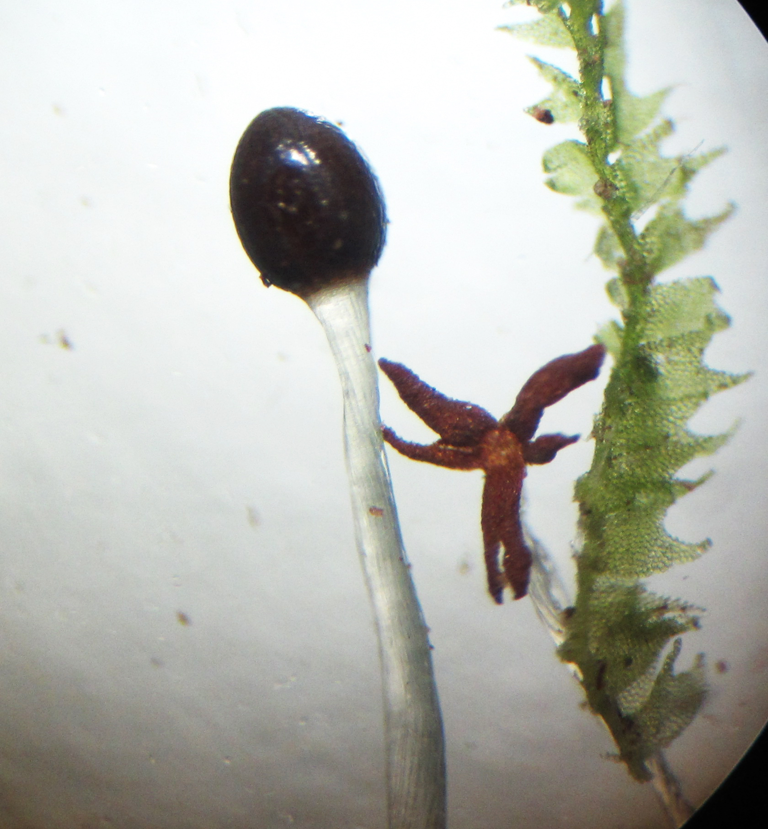
Liverwort

Liverworts, like moss are non-vascular plants.

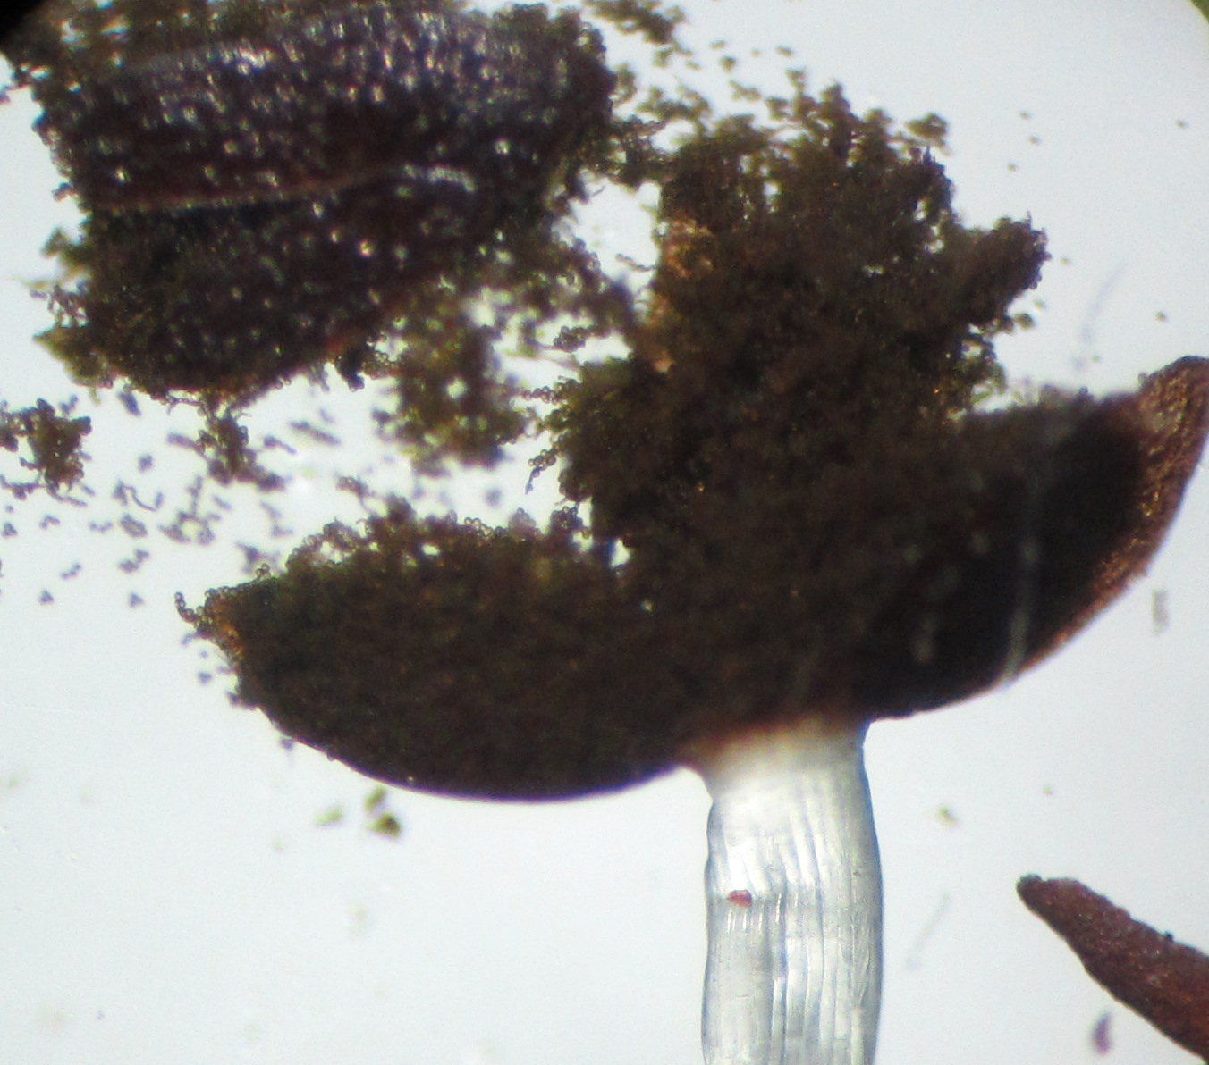
They are usually quite small, often have lobed leaves, and the sporophyte opens like a flower to release spores. The seta (stem on the capsule) is often silvery in appearance.

